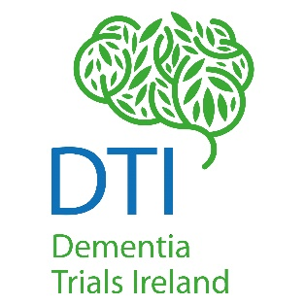
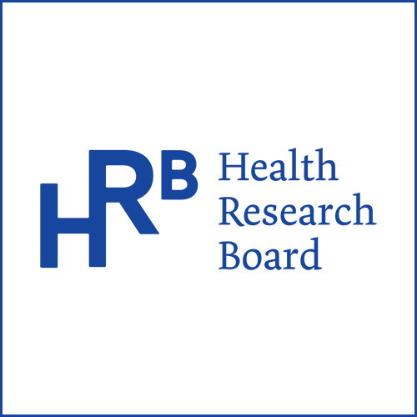
Dementia Trials Ireland
Annual Seed Funding Call 2022

About Dementia Trials Ireland
Dementia Trials Ireland (DTI) is a clinical trials infrastructure funded by the Health Research Board which aims improve the lives of individuals at risk or living with dementia by conducting high quality, internationally recognized, clinical trials throughout Ireland, addressing important and common problems. The ultimate goal is to enable every person at risk of, or living with dementia in Ireland, the opportunity to access clinical trials.

Purpose of the Fund
This seed funding call is aimed at early career researchers whose work will directly contribute to future trial development within Dementia Trials Ireland.
Funding proposals will be based on the following priorities: dementia in intellectual disability, dementia in nursing homes, palliative care in dementia, neuromodulation for Parkinson’s-related dementia/MCI:
- Development of Core Outcome Sets (COS)
- A priority setting partnership (PSP), supported by James Lind Alliance methodology
- Evidence synthesis that would support trial planning

Funding decisions will be based on
- The quality of the proposal and the likelihood of achieving its aims (clear rationale; objectives; description of methodology)

- The feasibility of the project being completed within the year and within the budget

- Whether the application is led by an early-career researcher

- Applicants are, or are willing to become, members of DTI

- How closely aligned the proposal will be with DTI strategic aims, namely, capacity and capability of dementia trials across the spectrum of the dementia life-course and trial methodologies, to increase the opportunity for people at risk of/with dementia to participate in clinical trials

- How it links in with existing HRB assets, particularly the HRB-TMRN

- The make-up of the applicant team (i.e. inclusion of early-career researchers)

Funding Available
The successful applicant will receive €12,000 for a one-year project that will contribute to future trial development within DTI

Terms and Conditions
- The project must be completed within 12 months of funding start date

- DTI will announce the details of successful grant application on various information platforms, including the lay summary.

- The grantee is responsible for the design and conduct of the project supported by the grant. This includes, but is not limited to, obtaining any necessary ethical approval, complying with data protection regulations, and obtaining informed consent, as appropriate.

- The successful grant applicant will commit to producing a (brief) 6-month report on progress.

- Successful grant applicants will be required to complete a MOU with DTI which will outline governance and financial conditions.

To apply for funding, please complete the application below and return to info@dementiatrials.ie by 5pm October 28th, 2022.

Key Dates:
Call open | September 27th, 2022
Applicant deadline | 5pm October 28th, 2022
Outcome | November 11th, 2022

Seed Funding Application Form

Please complete the application form and return it to info@dementiatrials.ie by 5pm, October 28th, 2022.

Name of Applicant

Applicant Email Address

Affiliation

Current Role

Are you affiliated to a Dementia Trials Site?
Supervisors name? (If applicable)

Team Members
Are you an early career researcher?
If awarded, would you be willing to become part of the DTI network?
Will the project be completed within 12 months?
Project Title:

Lay Description (200 words max)
Please give a very short description of the project in lay terms.

Describe Project (1000 words max)
Aim
Method/Approach
Stakeholders
Timeline
Key outputs and outcomes anticipated
Where will the project take place

Please provide a brief summary as to how your work will directly contribute to future trial development within DTI (250 words max)

Proposed Budget
Please provide an outline of the proposed budget for the project

Other Sources of funding
Please provide information of any other funding applications you are involved in, including the name of the organization, amount of funding applied for and the expected date of receipt of outcome, if applicable.

How will you involve Public and Patient Involvement? (100 words max)

